

**HO CHI MINH CITY UNIVERSITY OF TECHNOLOGY**

**AND EDUCATION**

**FALCUTY OF MECHANICAL ENGINEERING**

**DEPARTMENT OF MECHATRONICS**

**Optimization Algorithms for Inverse Kinematics of**

**Robot** **Fanuc m2000iA 900L**

|  |  |  |
| --- | --- | --- |
| COURSE CODE: |  |  |
| Teacher: | Do Van Hien |  |
| Member: | Huynh Thanh Phong | 22134009 |
|  | Pham Ngoc Phuc | 22314010 |
|  | Le Thi Hong Phuong | 22134011 |
|  | Vo Hong Quan | 22134012 |

Contents

1. INTRODUCTION. 3

2. TERMINOLOGY AND NOMENCLATURE 4

3. ROBOTIC MANIPULATOR MOBILITY 5

4. KINEMATIC 6

4.1 DH Table 6

4.2 Homogeneous Transformation Matrix 6

4.3 FORWARD KINEMATICS 7

4.4 INVERSE KINEMATICS 8

5. MATLAB CALCULATION 11

Appendix of pictures

Figure 1: Robotic manipulators 5

Figure 2: R-R-P structure 6

# INTRODUCTION.

Industrial robots have become integral to modern automation and manufacturing systems due to their flexibility, precision, and high efficiency in a wide range of applications. Among various robotic configurations, the 3-degree-of-freedom (DOF) RRP (Revolute-Revolute-Prismatic) manipulator is one of the most commonly used designs, offering simplicity while achieving significant functionality. The RRP configuration is widely applied in tasks such as assembly, material handling, and operations requiring precise linear motion of the end-effector, such as welding, painting, and packaging. Despite its simple structure, this configuration is capable of performing complex tasks in industrial settings.

To ensure precise control of robots, it is essential to analyze both forward and inverse kinematics. Forward kinematics focuses on determining the position and orientation of the end-effector based on the joint parameters, while inverse kinematics solves the inverse problem, calculating the joint parameters necessary to reach a desired position and orientation of the end-effector. These two kinematic problems provide the theoretical foundation for motion control and are critical for the integration of sophisticated control algorithms and optimization techniques in practical applications.

This report provides a detailed analysis of both forward and inverse kinematics for the 3-DOF RRP manipulator. Mathematical modeling methods, including the Denavit-Hartenberg (DH) parameterization, are used to derive the kinematic equations governing the manipulator’s motion. Instead of using real-world examples, we will rely on code to simulate and compute the kinematic values related to both forward and inverse kinematics, allowing us to verify and validate the proposed kinematic methods in theoretical conditions. Through this approach, the report emphasizes the importance of kinematic simulation in the design, testing, and optimization of robotic systems, ultimately enhancing their performance and functionality.

# TERMINOLOGY AND NOMENCLATURE

In robotic manipulators, each link has a coordinate system attached to it, called a frame, which defines its position and orientation. For example, in Figure 1a, frames are shown for the base (Link 0), Link 1, and Link 2. The relationships between these frames how one is positioned relative to another are described using transformation matrices.

At the free end of a manipulator, there is typically an end effector, which is the component that interacts with the environment. Common end effectors include grippers, which are used to hold tools or components. In Figure 1b, the manipulator’s end effector is a gripper, which fully constrains the tool it holds.

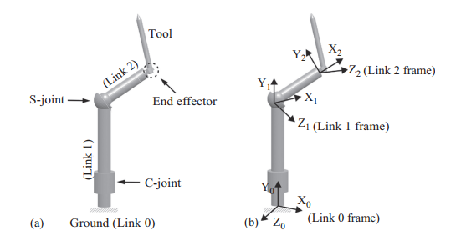

Figure 1: Robotic manipulators

# ROBOTIC MANIPULATOR MOBILITY

Gruebler’s Equation was introduced to determine the mobility of a linkage. This equation can also be applied to assess the mobility of robotic manipulators. For planar and spatial robotic manipulators, Gruebler’s Equations take the following forms:





Where L represents the number of links and J represents the number of joints. Planar manipulators typically use only 1-DOF joints, while spatial manipulators employ joints with 1, 2, or 3 degrees of freedom.

The notation R-R-P refers to the sequence and types of joints used in a manipulator, indicating the joint configurations that define a manipulator with 3 degrees of freedom.

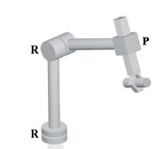

Figure 2: R-R-P structure

# KINEMATIC

## DH Table

|  |  |  |  |  |
| --- | --- | --- | --- | --- |
| **Link** | $a_{i}$**(mm)** | ${}_{i}$**($°$)** | $d_{i}$**(mm)** | ${}_{i}$**(rad)** |
| 1 | 0 | -90 |  | θ1 + 90 |
| 2 |  | -90 | 0 | -θ2 |
| 3 | 0 | 0 |  | 0 |

## Homogeneous Transformation Matrix

Transformation matrix between robot links:





where:





## FORWARD KINEMATICS

From modified DH table’s values, we can deduce that:

* Link 1:



* Link 2:



* Link 3:



From these transformation matrices, we can conclude that the transformation matrix to convert position from the end working point to the global coordinate origin is:





Position of End-Effector is:



## INVERSE KINEMATICS

From the relationship:



Rewriting:



Let:



For :



The relationship for  is:



Rewriting:



Simplified:



The coordinates are related to the angles as:



Similarly, for y:





# MATLAB CALCULATION

